

Quantitative Health Sciences/ JJN-3

9500 Euclid Ave, Cleveland, OH 44195

**To:** Candece Gladson **Date:** February 5, 2020

Graham Buchanan

Cancer Biology

**From:** Amy Nowacki **Re: Good vs. Poor Bev Responders – EGR1 & ILF3** **cytoplasmic staining**

**__________________________________________________________________________________________________**

We have measured the percent of tumor cells with cytoplasmic staining for EGR1 or ILF3 (quantitated as a percent) in 7 different fields from each xenograft tumor. For the Good Responder xenograft tumors, we used GBM tumors from two different patients (G59 and G39) that were injected and propagated in two (G59-7436 and G59-7911) or three (G39-6919, G39-7244 and G39-8007) different mice. For the Poor Responder xenograft tumors, we used GBM tumors from two different patients (G64 and G108) that were injected and propagated in two (G108-6451 and G108-6495) or three (G64-2787, G64-3209 and G64-3132) different mice.  We have seven fields measured on each mouse tumor for the EGR1 and ILF3 proteins, and we have determined the approximate percentage of tumor cells with cytoplasmic staining that are negative in expression, have weak expression, have 1+ (strong expression), or have 2+ (very strong expression) in each of the seven fields of tumor.  Our outcome will be the percentage of tumor cells with cytoplasmic staining that are WK+, 1+ or 2+ in expression for both EGR1 and ILF3.

1. Is there a difference in the percent of cells with cytoplasmic staining for EGR1 in the good responders versus the poor responders to bevacizumab?
2. Is there a difference in the percent of cells with cytoplasmic staining for ILF3 in the good responders versus the poor responders to bevacizumab?

**Our outcome is numeric (% of cells with cytoplasmic staining for either EGR1 or ILF3), thus we consider a linear model. We want to compare Good vs. Poor responders.**

**However, we do not have independence; we have 4 GBM xenograft tumors from different patients with each injected and propagated in 2-3 mice resulting in a total of 10 mouse tumors with 7 measures on each.**

**To take the dependence (clustering) into account, we turn to a linear mixed model.**

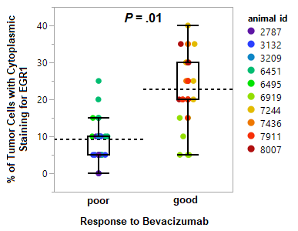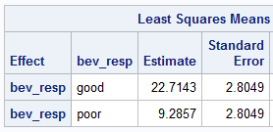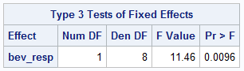**Linear mixed model (assuming compound symmetry):**

There is a significant difference in the percent of cells with cytoplasmic staining (WK+/1+/2+) for EGR1 in the poor responders versus the good responders to bevacizumab (*P* = .01); with a higher percentage of EGR1 cytosplasmic stained cells in the good responders (mean 23% good vs. 9% poor responders).

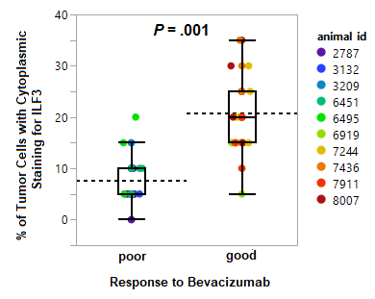

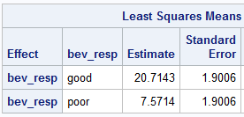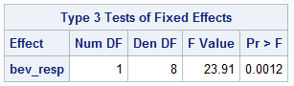

There is a significant difference in the percent of cells with cytoplasmic staining (WK+/1+/2+) for ILF3 in the poor responders versus the good responders to bevacizumab (*P* = .001); with a higher percentage of ILF3 cytoplasmic stained cells in the good responders (mean 21% good vs. 8% poor responders).